Online SIR Vendor Portal FAQs
Important:
- SIRS submitted via the Online SIR Vendor Portal should be submitted within 24 hours of incident occurrence.
- Online Vendor SIR replaces paper faxed SIR. If your primary method for submitting a SIR is the Online SIR Vendor Portal, you do not need to fax a paper SIR within 48 hours.
- Online Vendor SIR Portal will only notify parties within SDRC. Please ensure you are reporting to other appropriate agencies as needed (CCL/HCL, CPS/APS, Law Enforcement, Ombudsman)
- Always call or leave a voicemail for your assigned SC so that they can be aware that a SIR has been submitted, regardless if it is submitted via fax or the portal.
- If the portal is down and you need to report a SIR, download the SIR form and fax to (858-496-4327). SIR form can be found here: https://bit.ly/SDRCsirform
Acronyms: SDRC= San Diego Regional Center, RC= Regional Center, SC= Service Coordinator, SIRC= SIR Coordinator, Online SIR Vendor Portal = also known as Service Provider Portal (SPP)

Setup & Troubleshooting:
- How do vendors apply to use the Online SIR Vendor Portal?
  - Download the SPP Agreement Form linked on https://www.sdrc.org/special-incident-reporting.
    - Once completed, email the form to ebilling@sdrc.org.
  - Vendors can be set up as a Standard user or as a Superuser. Standard users can edit/submit SIRs. Superusers can submit SIRs and add new users onto the portal for their organization.

- Is there a limit to the number of users who can use the Online SIR Vendor Portal?
  - No, however, we recommend creating an account only for users who are allowed to create and/or submit SIRs.

- What do I do if I can’t reach the assigned SC within 24 hours of incident occurrence?
  - Submit the SIR via the Online SIR Vendor Portal and leave a voicemail for your SC so they are aware it has been submitted.

- Who do I contact for support or if the portal is down?
  - For issues regarding the incident, contact your SC.
  - For technical issues, contact your Superuser.
  - If the issue cannot be resolved at the vendor-level, contact SIRCs at sirs@sdrc.org.

Submitting SIRs:
- How do I submit a completed SIR using the Online SIR Vendor Portal?
  - Right-click the report from the SIR History Screen, and then click on “Submit.”
  - 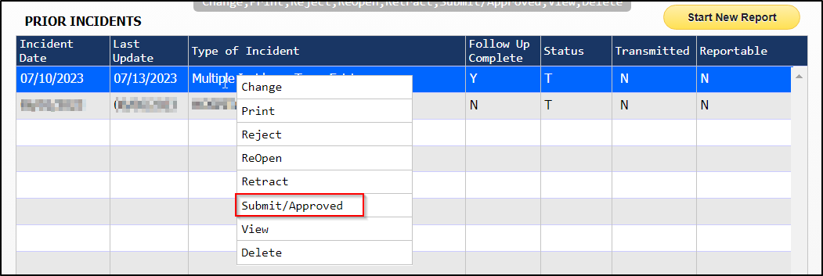

- Will vendors have access to all clients through the Online SIR Vendor Portal?
  - Vendors only have access to clients they have current authorizations for.

- Can vendors print SIRs through the Online SIR Vendor Portal?
  - Yes. Upon submission, the portal will display a pop-up asking if a PDF of the SIR is needed. Selecting “Yes” will prompt additional screens to email the PDF. You can then print the document from your desktop.

- Do we still to need call SDRC after submitting a SIR on the Online SIR Vendor Portal?
  - Yes. The vendor must make a phone call within 24hrs of the incident to ensure SC is aware of SIR.

- Once the SIR has been submitted, how do we include additional information to the report?
  - Contact the client’s assigned SC. They can coordinate with SIRCs to make changes.
  - Do not create and submit another report.

- How are SCs notified that a report has been submitted through the portal?
  - An email pop-up will display upon submitting the SIR. This will allow the vendor to notify the assigned SC that a SIR is ready for review.

- What happens if the vendor forgets to submit the SIR?
  - A SIR should be submitted as soon as the vendor becomes aware that one hasn’t been submitted. DDS does track vendors who do not report in a timely manner.

- I cannot find the SIR that I recently completed. Where did it go?
  - After submitting a SIR, the report will disappear from the SIR History Screen. This allows SDRC to fully review the completed report. If you need a copy of the SIR, contact sirs@sdrc.org.

Training:
- Is SIR training available for new users?
- The SIR Team offers two trainings:
  - SIR Vendor Training: Reporting agencies and timelines, reportable vs nonreportable, followup questions
  - SIRs & Words: How to write SIR narratives and case studies
- Trainings can be held in-person and via Zoom. To schedule a training, email sirs@sdrc.org.

